**IMPLEMENTING CRM FOR RESULT TRACKING OF A CANDIDATE WITH INTERNAL MARKS (DEV) - (SHORT-TERM)**

**TEAM ID:LTVIP2023TMID11578**

**TEAM LEADER:S.ASIFA**

**TEAM MEMBER:N.HEMALATHA**

**Delete Record (Course Details)**

Deleting Records of Course Details Object

1. Click on App Launcher on left side of screen.

2. Search Candidate Internal Result Card & click on it.

3. Click on Course details Tab.

4. Click on Arrow at right hand side on that Particular record.

5. Click delete and delete again.

### download (38).pngdownload (39).png Create Report

1. Click App Launcher

2. Select Candidate Internal Result Card App

3. Click reports tab

4. Click New Report.

5. Click the report type as Semesters with Course Click Start report.

6. Customize your report, in group rows select - Course Name, in group column Select Duration (In this way we are making a Matrix Report).

7. Click refresh

8. Click save and run

9. Give report name – Candidate Internal Result Report

10.Click Save

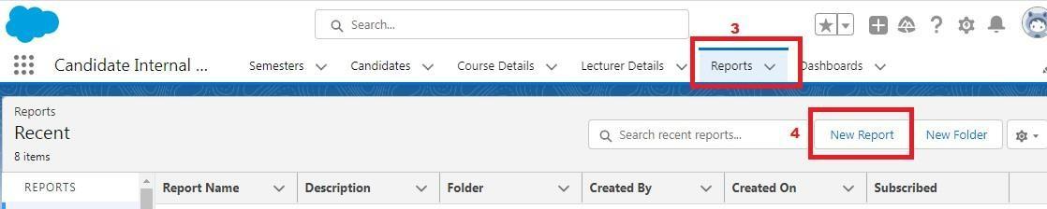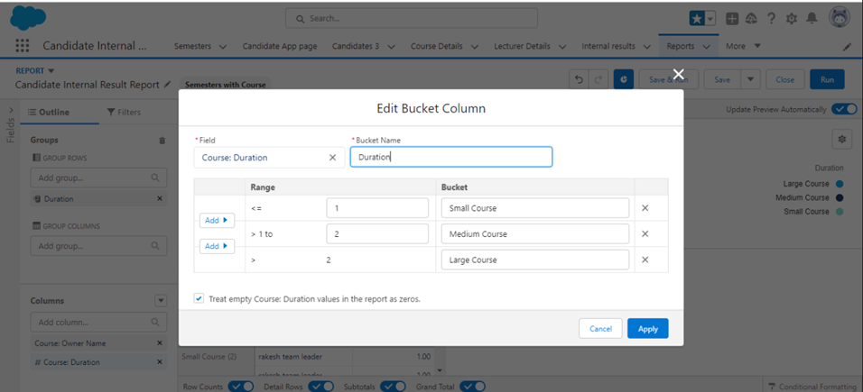1.    On the report builder page, locate the "Fields" pane on the left-hand side.

2.    Find the field for which you want to create a bucket field and drag it to the report preview section.

3.    Click on the field in the report preview to open the field properties.

4.    In the field properties, locate the "Summarize" option and click the drop-down arrow.

5.    Select "Bucket Field" from the available options.

6.    In the bucket field settings, define the buckets based on your requirements. You can specify the bucket ranges, labels, and groupings.

7.    Click "OK" or "Apply" to save the bucket field settings.

8.    Customize the report layout and add any additional fields or filters as needed.

9.    Once you are satisfied with the report setup, click "Save" to save the report.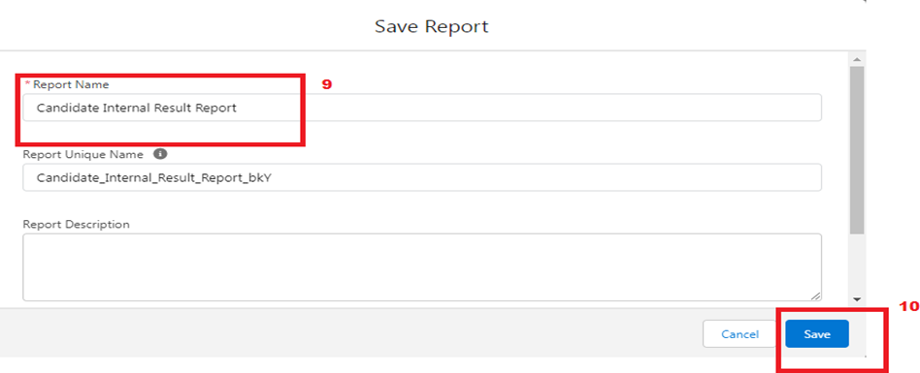

**View Report**

1. Click on App Launcher on left side of screen.

2. Search Candidate Internal Result Card App & click on it.

3. Click on Reports Tab.

4. Click on Candidate Internal Result Report and see records.

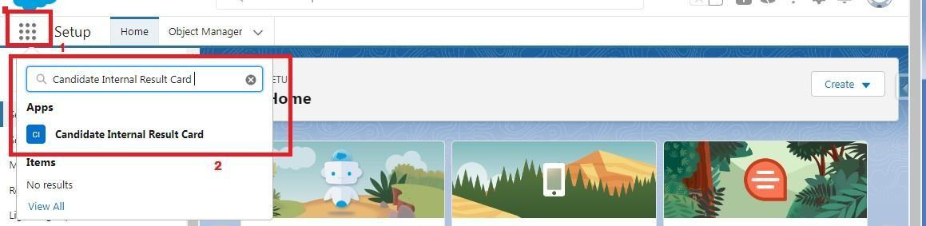

**Create Dashboard**

1. Click on Dashboards tab from the Candidate Internal Result Card application.

2. Click on new dashboard.

3. Give name- Candidate Internal Result Card

4. Click create

5.  Give your dashboard a name and click on +component

6. Select the Candidate Internal Result Report which you created.

7. For the data visualization select any of the chart, table etc. as per your choice/requirement.

8. Click add.

9. Click save.

### download (47).pngdownload (46).pngdownload (48).pngView Dashboard

1. Click on App Launcher on left side of screen.

2. Search Candidate Internal Result Card & click on it.

3. Click on Dashboard Tab.

4. Click on Candidate Internal Result Card see graph view of records

### download (49).png

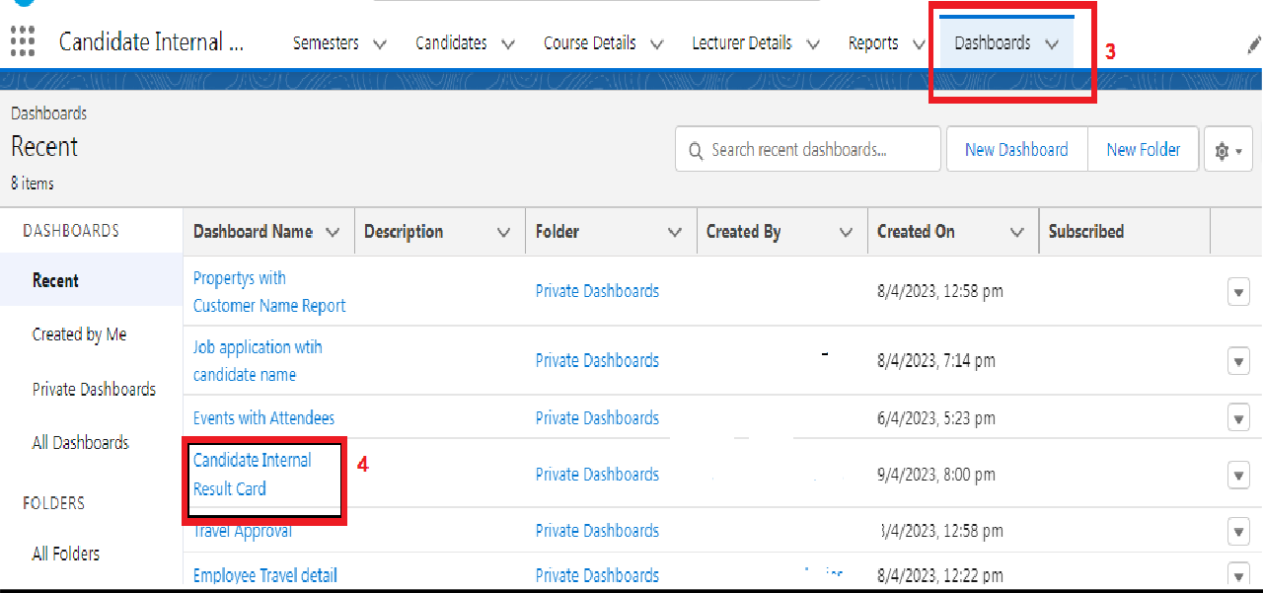

### Create A Screen Flow

1. Click on Gear icon and select setup

2. In Quick find Box enter flow and select the flows

3.Click on New flow and Select Screen flow 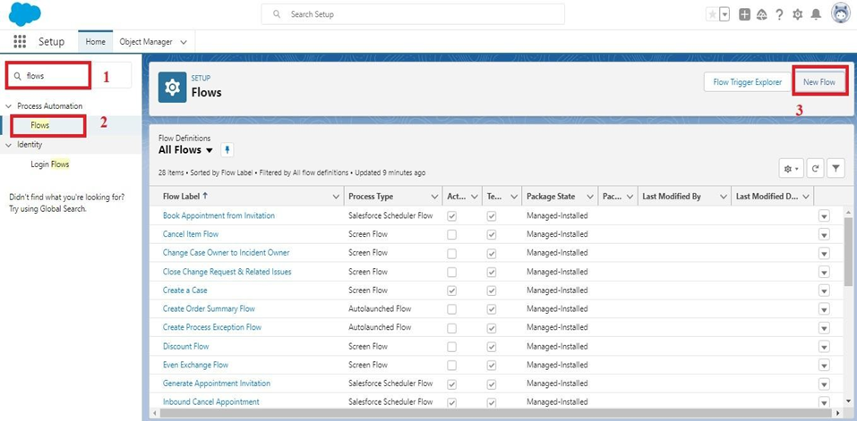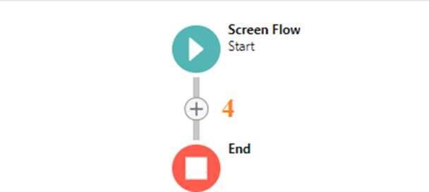

6.It will open the dialog box. Now give the label name and api name will be auto populated. These labels are for your screen Element.

     Label: Candidate info

     API Name: Candidate_Info (This field will be auto populated.)

     7..In search Component type text and drag the text component to canva and give the label and Api Name

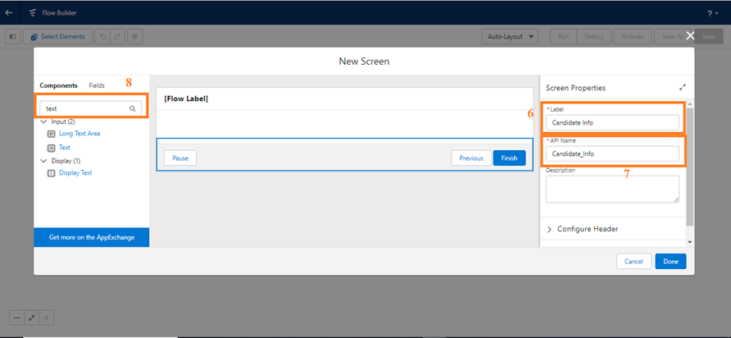

* 1. 8.Similarly, Add Email Component also.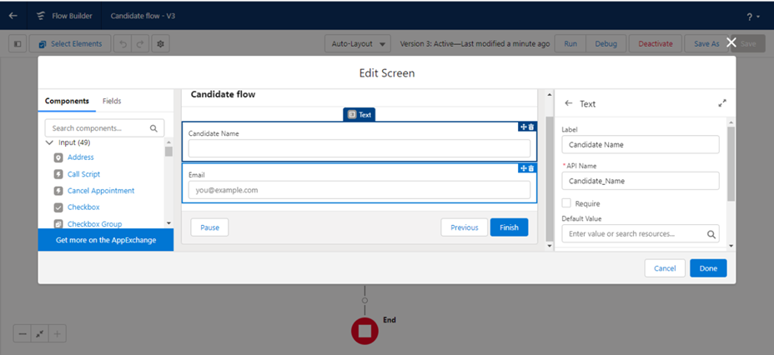

1. 9.Select (+)
2. 10.In search bar search for Create records and select the create records

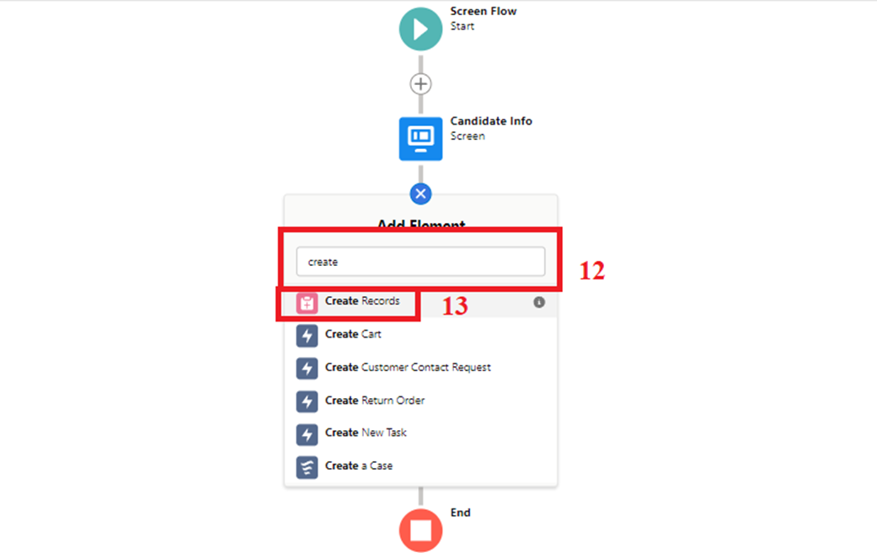

  11.It will open you the details section and give the label as follows:

Label: Create candidate Records

      API Name: Create_candidate_Records

     Then check the use separate resources and literal values Search for candidate Object

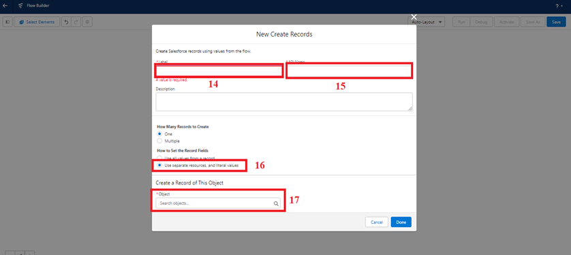

12.Under field type name and select the name and select the candidate_name under Screen Component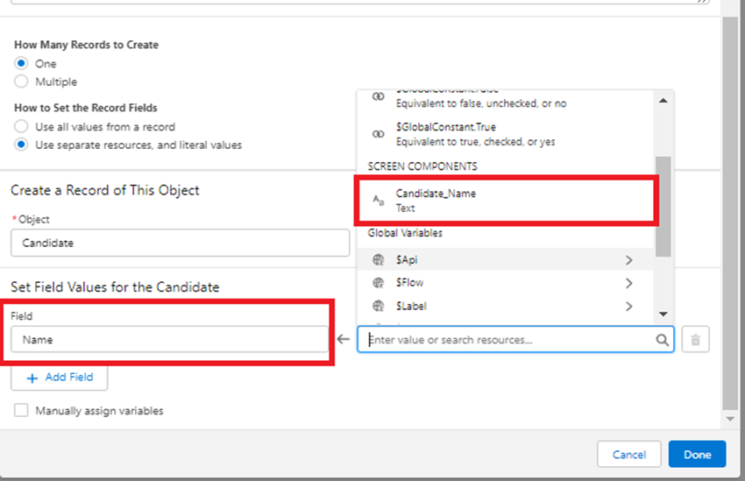

13.Click on Done

      14.Click on Save. It will open you details canva and give the details as follows:

      15. Select (+)

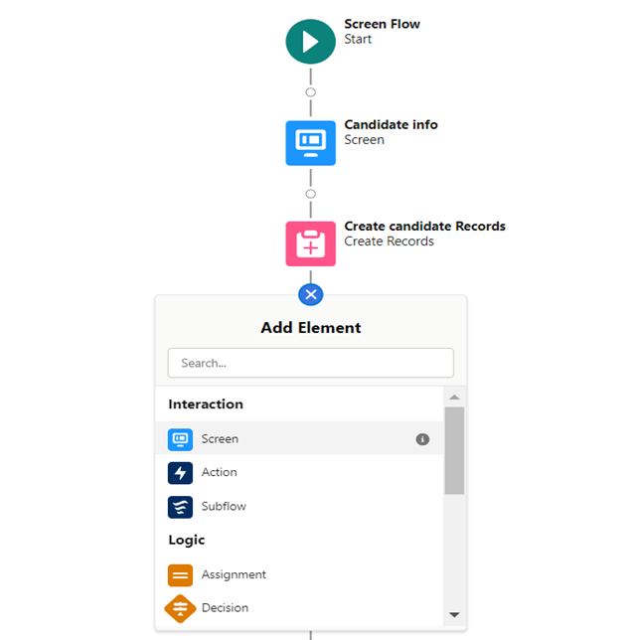

 16.Select the Action  element from the drop down.

     17.Enable Body and Give Hi {!Candidate_Name}, Welcome to the semester

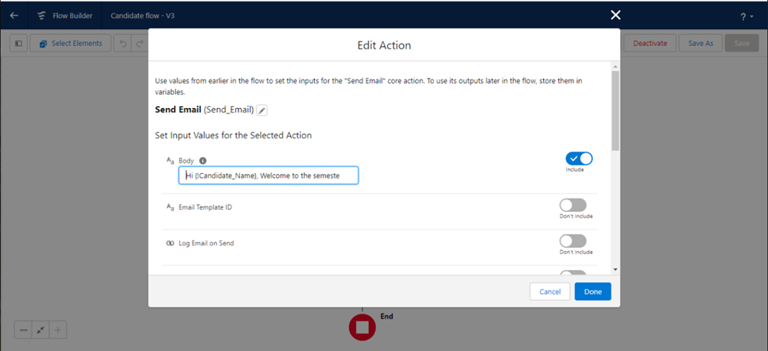

18.Enable Recipient Address List and Give {!Email.value}

**Create An App Page**

1. Click on the Gear icon and select set up.

2. In Quick Find Box . Type app Builder and select the lighting app builder

3. Select New

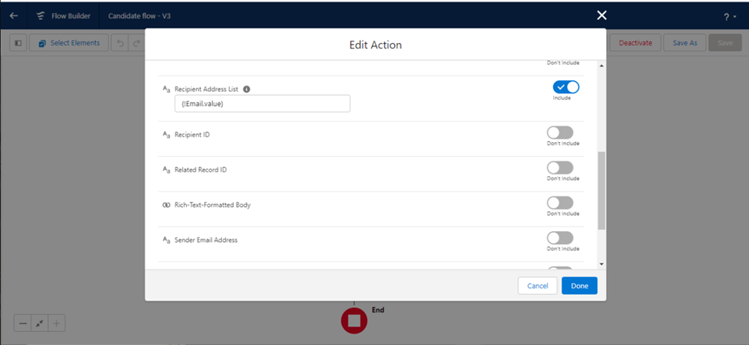

 19.Enable Subject and Give Welcome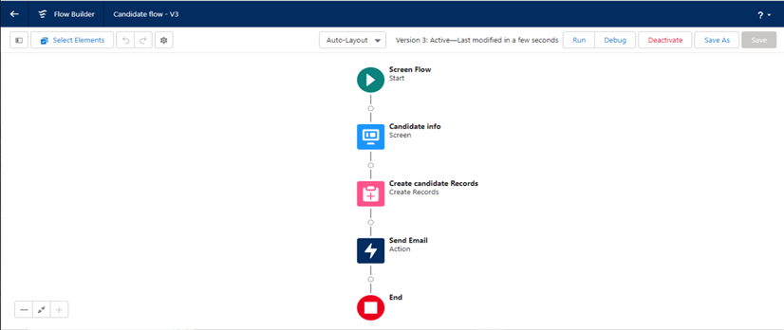

Flow label: Candidate flow

      Flow API Name: Candidate_flow (this will be auto populated)

     20.Click on save

     21.Click on the Activate.

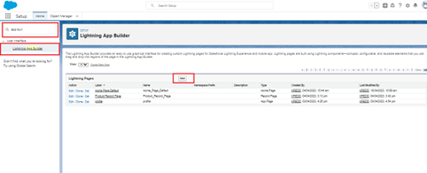

4.Select the App page and click on Next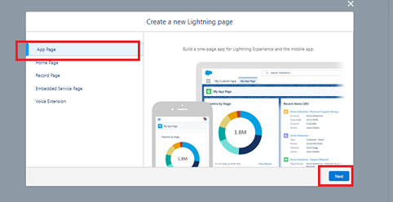

6. 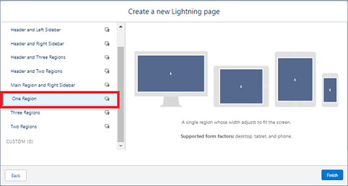.

1. Type the flow in the search bar and select the flow component and drag the component to the Add components here.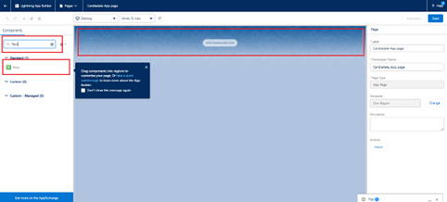
2. 8. After dragging the component, give the flow label in the flow search and then click on save and then click on activate. Flow label:Candidate flow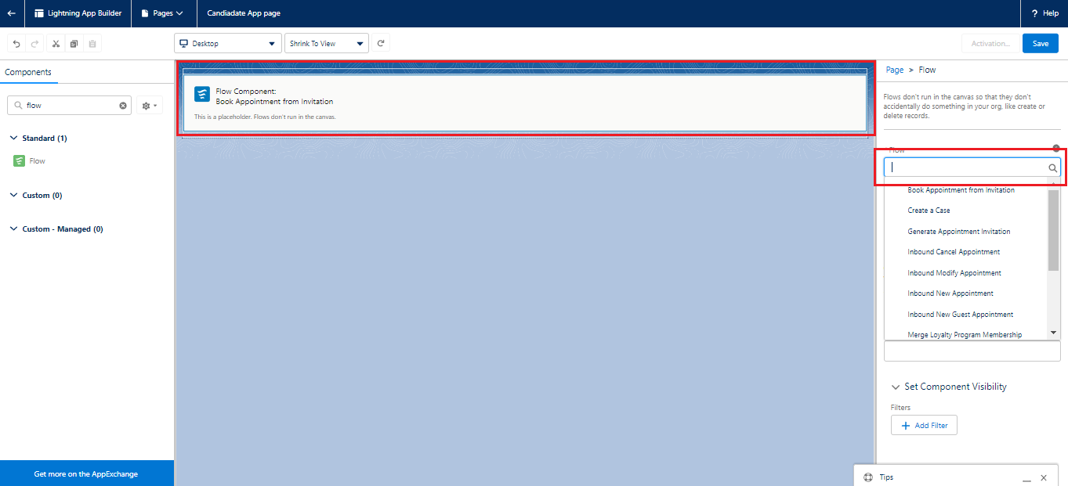
3. 9. After clicking on the activate it will open a page and then select the lightning experience and select the app and then click on add page to the app.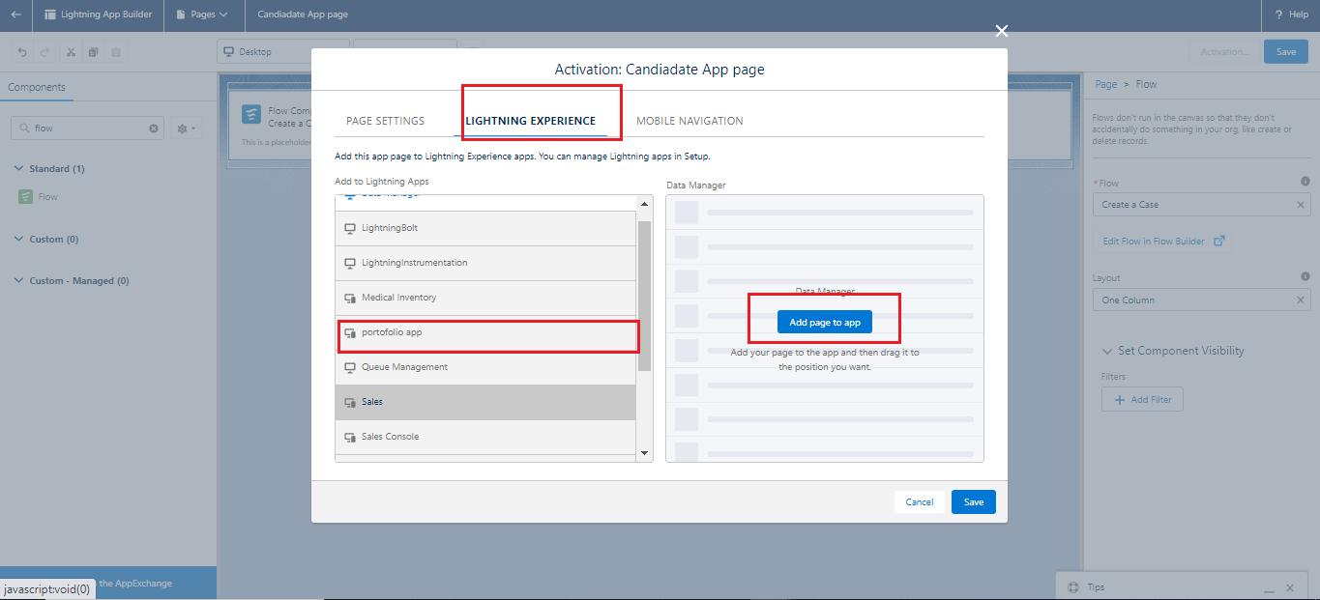

**Field Update Using Trigger**

1. Whenever a internal Marks is inserted if the marks is greater than or equal to 200 it must update the status field to Pass or else it must update to fail
2. 1. Go to the gear icon and select the developer console.
3. 2. From the menu bar click on file and select Apex class.
4. 3. Now give the class name as InternalmarksHandler
5. 4. Now Write the  below code
6. 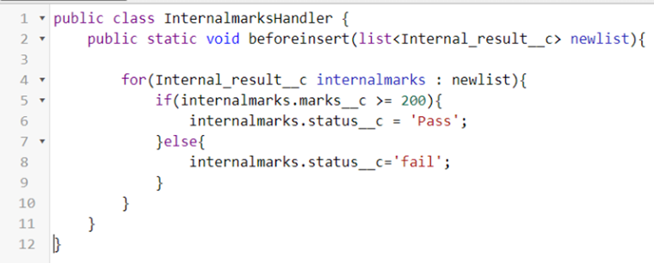
7. public class InternalmarksHandler {
8. public static void beforeinsert(list<Internal_result__c> newlist){
10. for(Internal_result__c internalmarks : newlist){
11. if(internalmarks.marks__c >= 200){
12. internalmarks.status__c = 'Pass';
13. }else{
14. internalmarks.status__c='fail';
15. }
17. }
19. }
20. }
22. 5. From the menu bar click on file and select Apex trigger.
23. 6. Now give the trigger name as Internalmarks
24. 7. Now write the below code
25. 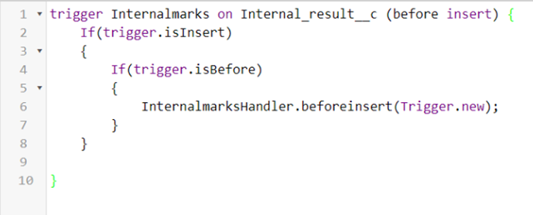

trigger Internalmarks on Internal_result__c(before insert,after update) {

    If(trigger.isInsert)

    {

        If(trigger.isBefore)

        {

            InternalmarksHandler.beforeinsert(Trigger.new);

        }

    }

}

1. 8.Trigger Working as follows:  
      In the following record Marks field is given as 300,Now trigger triggers and  
      status changes to Pass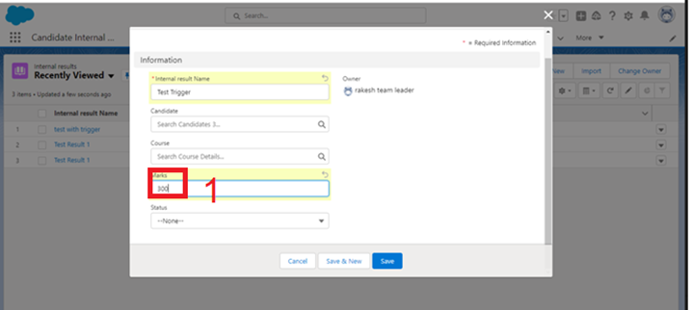
2. 